An alle
Eltern/Erziehungsberechtigten
der Schule Bad Zurzach

Bad Zurzach, 20. März 2020

Further procedure until 16.04.2020

Dear parents and guardians

Last Friday we had to inform you at very short notice about the federal and cantonal requirements for the containment of the corona virus. This was followed on Monday by specific comments on the organisation of teaching, learning and working at primary schools.

We all hope that the suspension of attendance lessons after the spring holidays can be lifted. In the current situation, however, it is also to be expected that the school will have to remain closed for on-site teaching in the longer term.

In this extraordinary situation, we are all particularly challenged. Together we want to approach the goal of making learning and teaching possible in the coming weeks with confidence, commitment and mutual trust. In doing so, we will also go down unfamiliar paths, try out new things, make some mistakes and learn some things from them. We are aware that many families are in the middle of a great challenge. Extended work shifts, home office, caring for relatives and, in addition, lessons at home can become an unsolvable task. We see it as our task to support you as much as possible and not to burden you additionally. Stay in regular contact with us, report your wishes and concerns, and share your worries with us.

You can find information on ongoing changes at www.schulebadzurzach.ch. If you have any questions or concerns, please feel free to contact us at any time.

We wish you all the best and good health.

Kind regards

SCHULE BAD ZURZACH SCHULE BAD ZURZACH
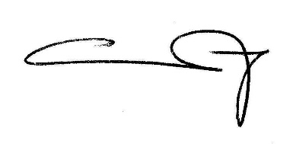
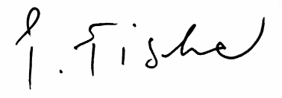
KINDERGARTEN & PRIMARSCHULE KINDERGARTEN & PRIMARSCHULE

Christina Kruthoff Philipp Fischer
Hauptschulleitung Schulleitung
Kindergarten/Unterstufe (1.-3.) Mittelstufe (4.-6.)

